Innovation Zone update

Purpose:
For information.

Summary
The report includes background details about the Zone, latest developments and Members’ involvement.

Recommendation
That the members note the report.
Actions
- Members to encourage attendance at the Innovation Zone and get involved during the Conference.

- IZ working group to provide advice and guidance where necessary.

Contact officer: Lusi Manukyan
Position: Improvement Support Adviser
Phone no: 0207 187 7347
Email: lusi.manukyan@local.gov.uk

Innovation Zone update
Background
- In addition to specific support offers such as the Behavioural Insights and Design in the Public Sector programmes, the LGA’s innovation programme includes sharing examples of local government and wider public sector good practice. This helps equip councils with tools and confidence to use innovative approaches to solve their challenges.

- The innovation programme includes our three-day Innovation Zone, which is a vibrant, creative space and programme within the LGA’s Annual Conference and Exhibition, taking place from 2-4 July 2019 in Bournemouth.
Theme and criteria
- Following a paper presented to the Board on 25 October 2018 and following an email consultation with members, it was agreed that this year’s overall theme for the Innovation Zone will be ‘Take the Plunge’, encouraging organisations to present brave, innovative ideas that have paid off.

- Based on the comments and suggestions through the consultation the following criteria have been agreed:

  - The nature of the innovation

  - How much the innovation has improved outcomes

  - How many savings the project has made

  - How relevant the innovation is to councils

  - How interactive/interesting the IZ sessions can be made.

- We will also continue to consider and invite innovations from around the world, ambitious innovations in their early stages as well as those that have delivered tangible benefits.

Timeline
- The Innovation Zone opened for submissions in the first week of December 2018, with a deadline of 28 January 2019 and has been promoted through a number of channels including social media, the LGA website and various bulletins.

- We will provide a progress report, including a shortlist of Innovation Zone participants, for the Improvement and Innovation Board meeting on 28 March 2019. The IIB Innovation Zone working group will have overall oversight of the project.

- Appendix 1 provides a full proposed project timeline with details of individual activities and deadlines.
Implications for Wales
- None.
Financial Implications
- There are no financial implications arising from this report.
Next steps
- Members to encourage attendance at the Innovation Zone and get involved during the Conference.

- IZ working group to provide advice and guidance where necessary.

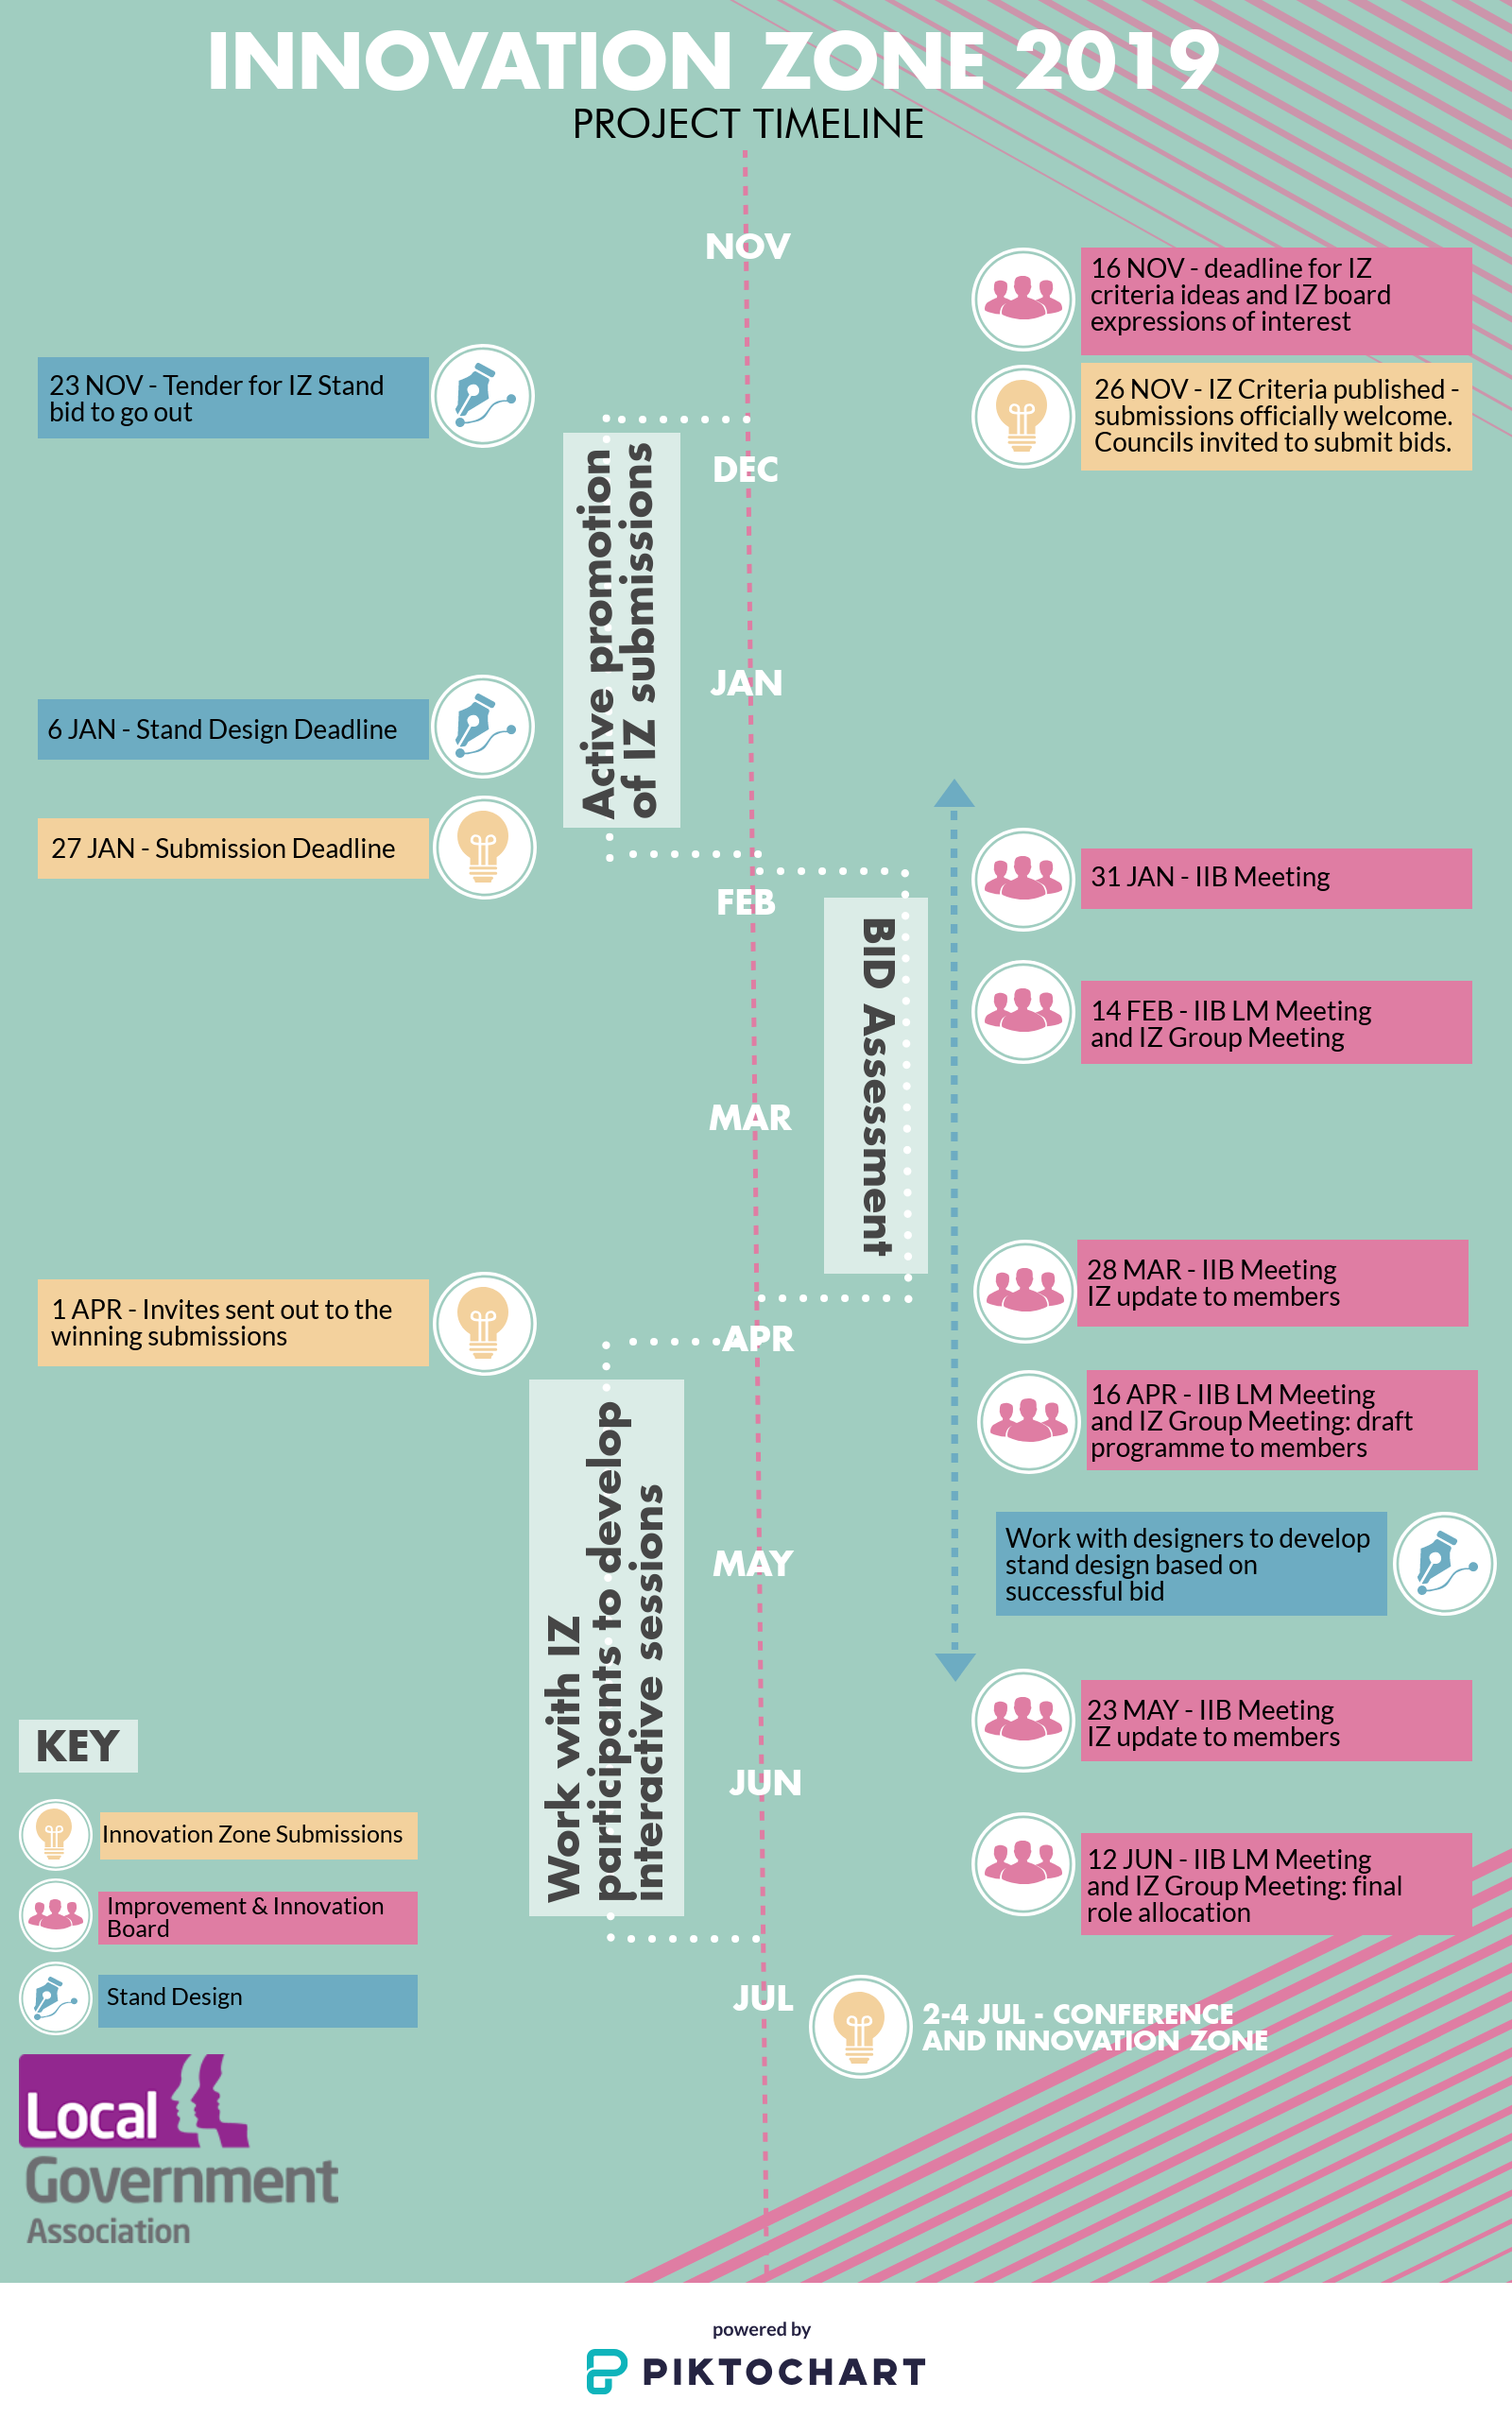
Appendix 1. Innovation Zone Project timeline

